VISVESVARAYA TECHNOLOGICAL UNIVERSITY

JnanaSangama, Belgaum-590018,Karnataka,India.



**A Project Phase One Report on**

**“WATER MONITORING SYSTEM FOR HYDROPONICS AGRICULTURE”**

**in**

**ELECTRONICS AND COMMUNICATION ENGINEERING**

**by**

1. **Prajwal Sampgaon 2KL16EC050**
2. **Pavankumar Budihal 2KL16EC048**
3. **Meghana PR 2KL16EC035**
4. **Apoorva Sangam 2KL16EC012**

**UNDER THE GUIDANCE OF**

**Prof. SUSHANT JADHAV**

**DEPARTMENT OF ELECTRONICS AND COMMNUNICATION ENGINEERING**

**K. L. E. Dr. M. S. SHESHGIRI COLLEGE OF ENGINEERING AND TECHNOLOGY**

**BELGAVI– 590008**

**(2019-2020)**



**Department of Electronics and Communication Engineering**

**CERTIFICATE**

Certified that the Project Phase One work entitled **“Water Monitoring System for Hydroponics Agriculture”,** is carried out by **, Prajwal Sampgaon(2KL16EC050), Pavankumar Budihal (2KL16EC048), Meghana PR (2KL16EC035), Apoorva Sangam (2KL16EC012**) are bonafied students of **Department of Electronics and Communication Engineering, K.L.E. Dr. M.S. Sheshgiri College of Engineering and Technology, Belagavi,** in partial fulfillment for the award of **Bachelor of Engineering** in Electronics and Communication of the **Visvesvaraya Technological University, Belagavi,** during the year **2019 -20.** It is certified that all correction/suggestions indicated have been incorporated in the report and has been approved as it satisfies the academic requirements in respect to **Project Phase One** prescribed for the said degree.

**Project Coordinator Guide**

**HOD Principal**

**K. L. E. Dr. M. S. SHESHGIRI COLLEGE OF ENGINEERING AND TECHNOLOGY**

 Department of Electronics & Communication Engineering

Vision and Mission of the Department of Electronics and Communication Engineering are:

VISION

To be the center of excellence for education and research in Electronics and Communication Engineering

MISSION

1. To achieve academic excellence by encouraging active student-teacher relation.
2. To groom students with high moral and ethical standards.
3. To promote socially-relevant research and development activities.
4. To collaborate with institutions and industries for knowledge sharing, employability and entrepreneurship.
5. To encourage life-long learning in developing innovative products and services.

PROGRAM EDUCTIONAL OBJECTIVES(PEOs)

The educational objectives of the undergraduate program in Electronics and Communication Engineering are:

1. To impact the knowledge and skills to meet the needs of current and emerging technologies in Electronics and Communication Engineering.
2. To enable active pursuance of life-long study in Electronics and Communication Engineering in order to develop innovative technologies for quality products and services.
3. To cultivate the ethical and socially relevant research and development activities.
4. To impact effective communication skills for success in interdisciplinary and multicultural teams.

 **K. L. E. Dr. M. S. SHESHGIRI COLLEGE OF ENGINEERING AND TECHNOLOGY**

Department of Electronics & Communication Engineering

#### **Program Outcomes: (POs)**

1 **Engineering Knowledge:**Apply the knowledge of mathematics, science, engineering fundamentals, and an engineering specialization to the solution of complex engineering problems.

2.**Problem Analysis**: Identify, formulate, research literature, and analyze complex engineering problems reaching substantiated conclusions using first principles of mathematics, natural sciences, and engineering sciences.

3.**Design/development of Solutions**: Design solutions for complex engineering problems and design system components or processes that meet the specified needs with appropriate consideration for the public health and safety, and the cultural, societal, and environmental considerations.

4.**Conduct Investigations of Complex Problems**: Use research-based knowledge and research methods including design of experiments, analysis and interpretation of data, and synthesis of the information to provide valid conclusions.

5.**Modern Tool usage**: Create, select, and apply appropriate techniques, resources, and modern engineering and IT tools including prediction and modelling to complex engineering activities with an understanding of the limitations.

6. **The Engineer and Society**: Apply reasoning informed by the contextual knowledge to assess societal, health, safety, legal and cultural issues and the consequent responsibilities relevant to the professional engineering practice.

7. **Environment and Sustainability**: Understand the impact of the professional engineering solutions in societal and environmental contexts, and demonstrate the knowledge of, and need for sustainable development.

8.**Ethics**: Apply ethical principles and commit to professional ethics and responsibilities and norms of the engineering practice.

9.**Individual and Team Work**: Function effectively as an individual, and as a member or leader in diverse teams, and in multidisciplinary settings.

10.**Communication:**Communicate effectively on complex engineering activities with the engineering community and with society at large, such as, being able to comprehend and write effective reports and design documentation, make effective presentations, and give and receive clear instructions.

11.**Project Management and Finance**: Demonstrate knowledge and understanding of the engineering and management principles and apply these to one’s own work, as a member and leader in a team, to manage projects and in multidisciplinary environments.

12. **Life-long Learning:**Recognize the need for, and have the preparation and ability to engage in independent and life-long learning in the broadest context of technological change.

### **Program Specific Outcomes:(PSOs)**

1.  Demonstrate theoretical and practical knowledge of Electronic and Communication Engineering.

2.  Exhibit the technical and soft skills leading to employability.

3. Actively pursue lifelong learning to develop innovative products and services.

 **K. L. E. Dr. M. S. SHESHGIRI COLLEGE OF ENGINEERING AND TECHNOLOGY**

Department of Electronics & Communication Engineering

Project Group No:14

|  |  |  |
| --- | --- | --- |
| Student Name: | USN: | Signature: |
| Prajwal Sampgaon | 2KL16EC050 |  |
| Pavankumar Budihal | 2KL16EC048 |  |
| Meghana PR | 2KL16EC035 |  |
| Apoorva Sangam | 2KL16EC012 |  |

|  |
| --- |
| Guide |
|  |

**Mapping of Program Outcomes(POs):**

|  |  |  |  |  |  |  |  |  |  |  |  |  |
| --- | --- | --- | --- | --- | --- | --- | --- | --- | --- | --- | --- | --- |
| **Project Title** | **PO1** | **PO2** | **PO3** | **PO4** | **PO5** | **PO6** | **PO7** | **PO8** | **PO9** | **PO 10** | **PO 11** | **PO 12** |
|  |  |  |  |  |  |  |  |  |  |  |  |  |

**Mapping of Program Specific Outcomes (PSOs):**

|  |  |  |  |
| --- | --- | --- | --- |
| **Project Title** | **PSO1** | **PSO2** | **PSO3** |
| **Water monitoring system for hydroponics agriculture** |  |  |  |

**TABLE OF CONTENT**

1. **INTRODUCTION**
2. **LITERATURE SURVEY**
3. **RASPBERRY PI3**
4. **DS18B20 TEMPERATURE SENSOR**
5. **SOIL MOISTURE SENSOR**
6. **PLANT GROWTH LIGHTS**
7. **NUTRIENTS**
8. **AIR PUMP**
9. **METHODOLOGY**
10. **ADVANTAGES**
11. **DISADVANTAGES**
12. **REFERENCES**

**Introduction**

What is hydroponics?

Hydroponics comes from Latin language and it means working water.

“ Hydro” means “ water” “Ponos” means “ labor”

“Growing plants in water without using soil

Hydroponics is a technique in which plant grow without using the soil. This technique take cares that the plant gets all nutrients which are required from the water solution. There so many types of hydroponic techniques. One of the techniques is water culture(WC).

Water culture is a technique that supplies the nutrient directly to the roots of the plant until the plant can be harvested. In this technique the plant root will be always submerged into the water containing nutrient and oxygen.

**Literature survey**

Hydroponics is one of the best alternatives for plants on narrow land. There have been several papers published in several journals in hydroponics system in recent years; they suggest how hydroponics plant systems work.

According to P Sihombing, N A Karina, J T Tarigan and M I Syarif that the waste nutrients from hydroponics plants can be reused.

Another paper is the role of hydroponics technique as a standard methodology in various aspects of land biology researches, this paper provides a basic idea of hydroponic water culture. This paper also discuss the methodology used to measure pH values of the sensors and also maintains water levels in hydroponic reserviors. This paper also address the difficulties of control that occurred during automation.

**Raspberry pi3**

The Raspberry Pi is a low cost, credit-card sized computer that plugs into a computer monitor or TV, and uses a standard keyboard and mouse. It is a capable little device that enables people of all ages to explore computing, and to learn how to program in languages like Scratch and Python.

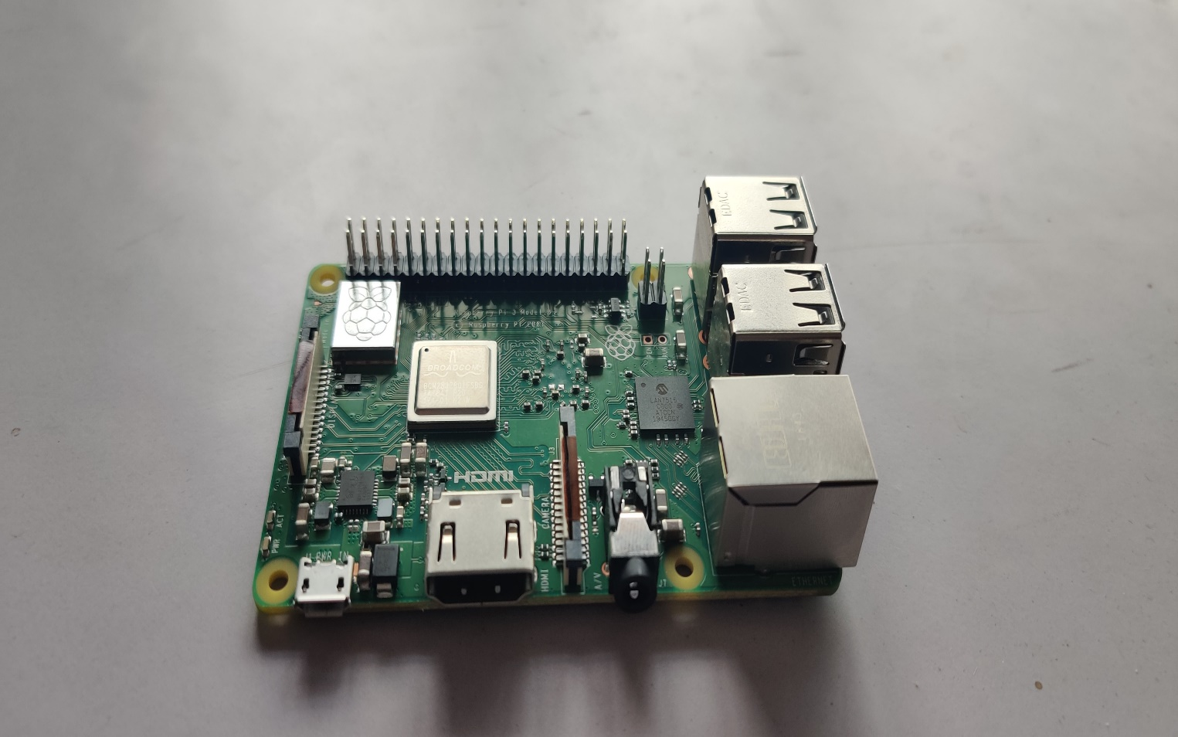

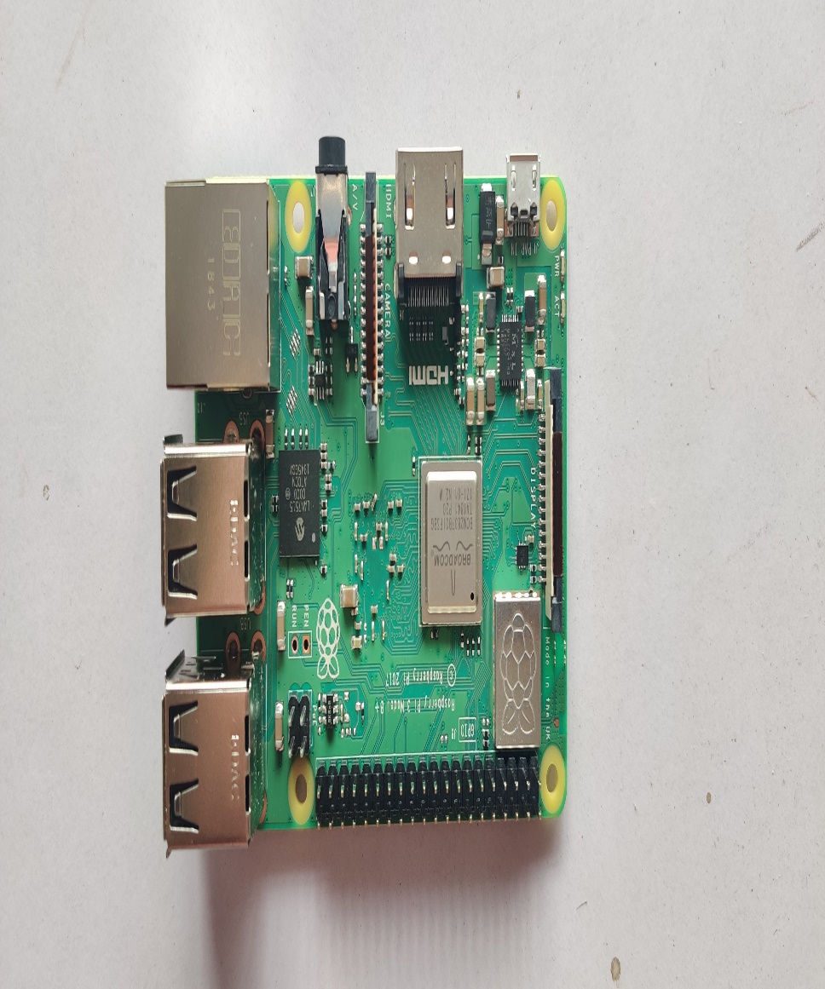

**DS18B20 Temperature sensor**

* The DS18B20 Digital Thermometer provides 9 to 12-bit (configurable) temperature readings which indicate the temperature of the device. The DS18B20 communicates over a 1-Wire bus Power supply range is 3.0V to 5.5V
* Measures temperatures from -55°C to +125°C. Fahrenheit equivalent is -67°F to +257°F
* ±0.5°C accuracy from -10°C to +85°C
* Converts 12-bit temperature to digital word in 750 ms (max.)
* The DS18B20 Sensor in our Hydroponic System is used to continuously monitor the Temperature of the nutrient solution which helps in reflecting the changes in blynk application. The nutrient solution has to maintain a temperature of 15-30 degrees Celsius for growing spinach.

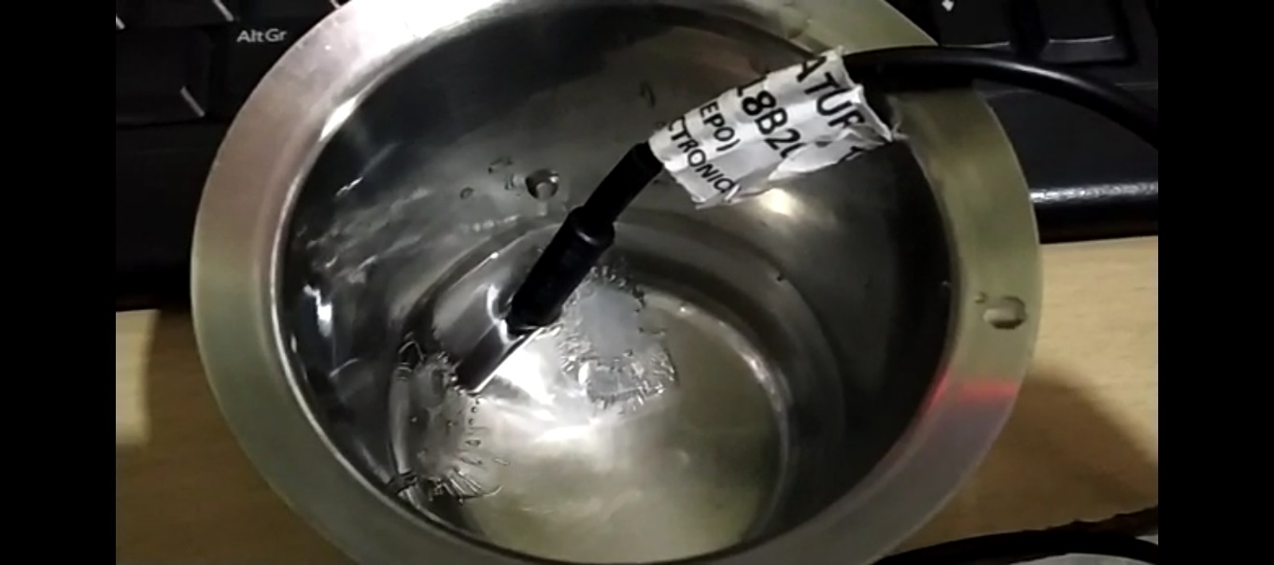

Temperature sensor dipped in ice water

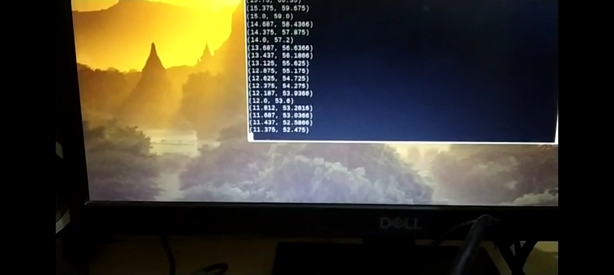

Monitor displaying the temperature



Temperature sensor exposed to environment

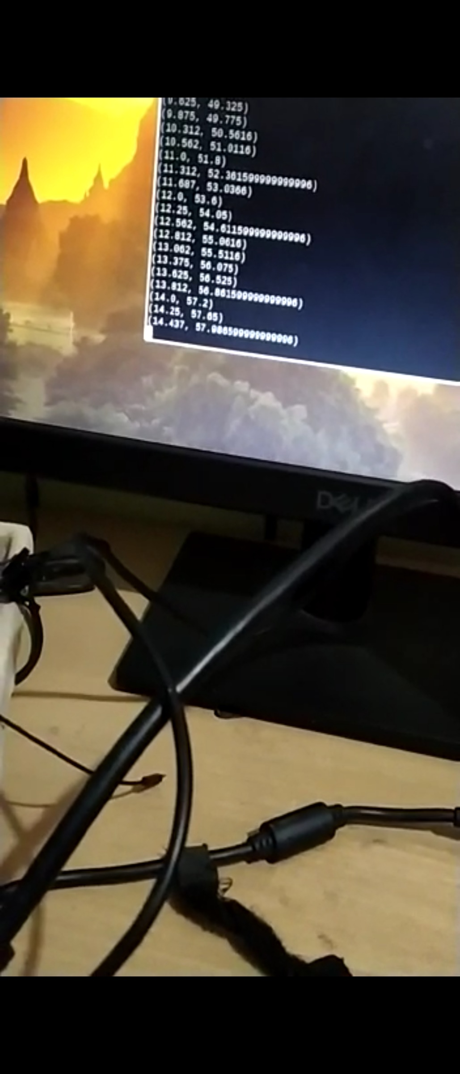

Monitor displaying temperature

**Soil moisture sensor**

* This is a simple water sensor can be used to detect soil moisture when the soil moisture deficit module outputs a high level, and vice versa output low. Use this sensor produced an automatic plant waterer device, so that the plants in your garden without people to manage.
* Sensitivity adjustable the blue digital potentiometer adjustment
* Operating voltage 3.3V-5V
* Module dual output mode, digital output, analog output more accurate.
* With fixed bolt hole for easy installation
* PCB size: 3cm * 1.6cm

Power indicator (red) and digital switching output indicator (green)

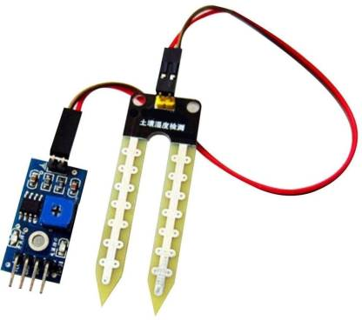

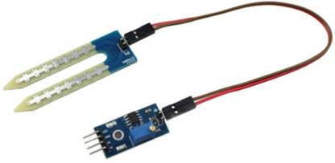

**PLANT GROWTH LIGHTS**

**Specifications**:   
Item Type: Grow Light  
Input Voltage: AC220V  
LED Chips: 2835 SMD   
Power:3W  
Full Spectrum: Red+Blue   
LED Quantity: 60pcs (41pcs Red+19pcs Blue)  
Lumens: 250lm   
Base Type: E27   
CRI: 70-75  
Material: PC  
Size: Dia 48*50mm

**Features**:

-Contains no harmful elements, environmental friendly.

-Low power consumption & high luminous efficiency.

-Universal E27 bulb makes setup & use easy.

-Ideal for all plants which work on soil or hydroponics methods of growing in any indoor environment.

**Red / Blue light important for plants:**  
1. Red light is very important to plant reproduction. Phytochrome pigments absorb the red and far red portions of the light spectrum and regulate seed germination, root development, tuber and bulb formation, dormancy, flowering and fruit production.

2. Blue light stimulates Chlorophyll production more than any other color, encouraging thick leaves, strong stems and compact vegetative growth. 

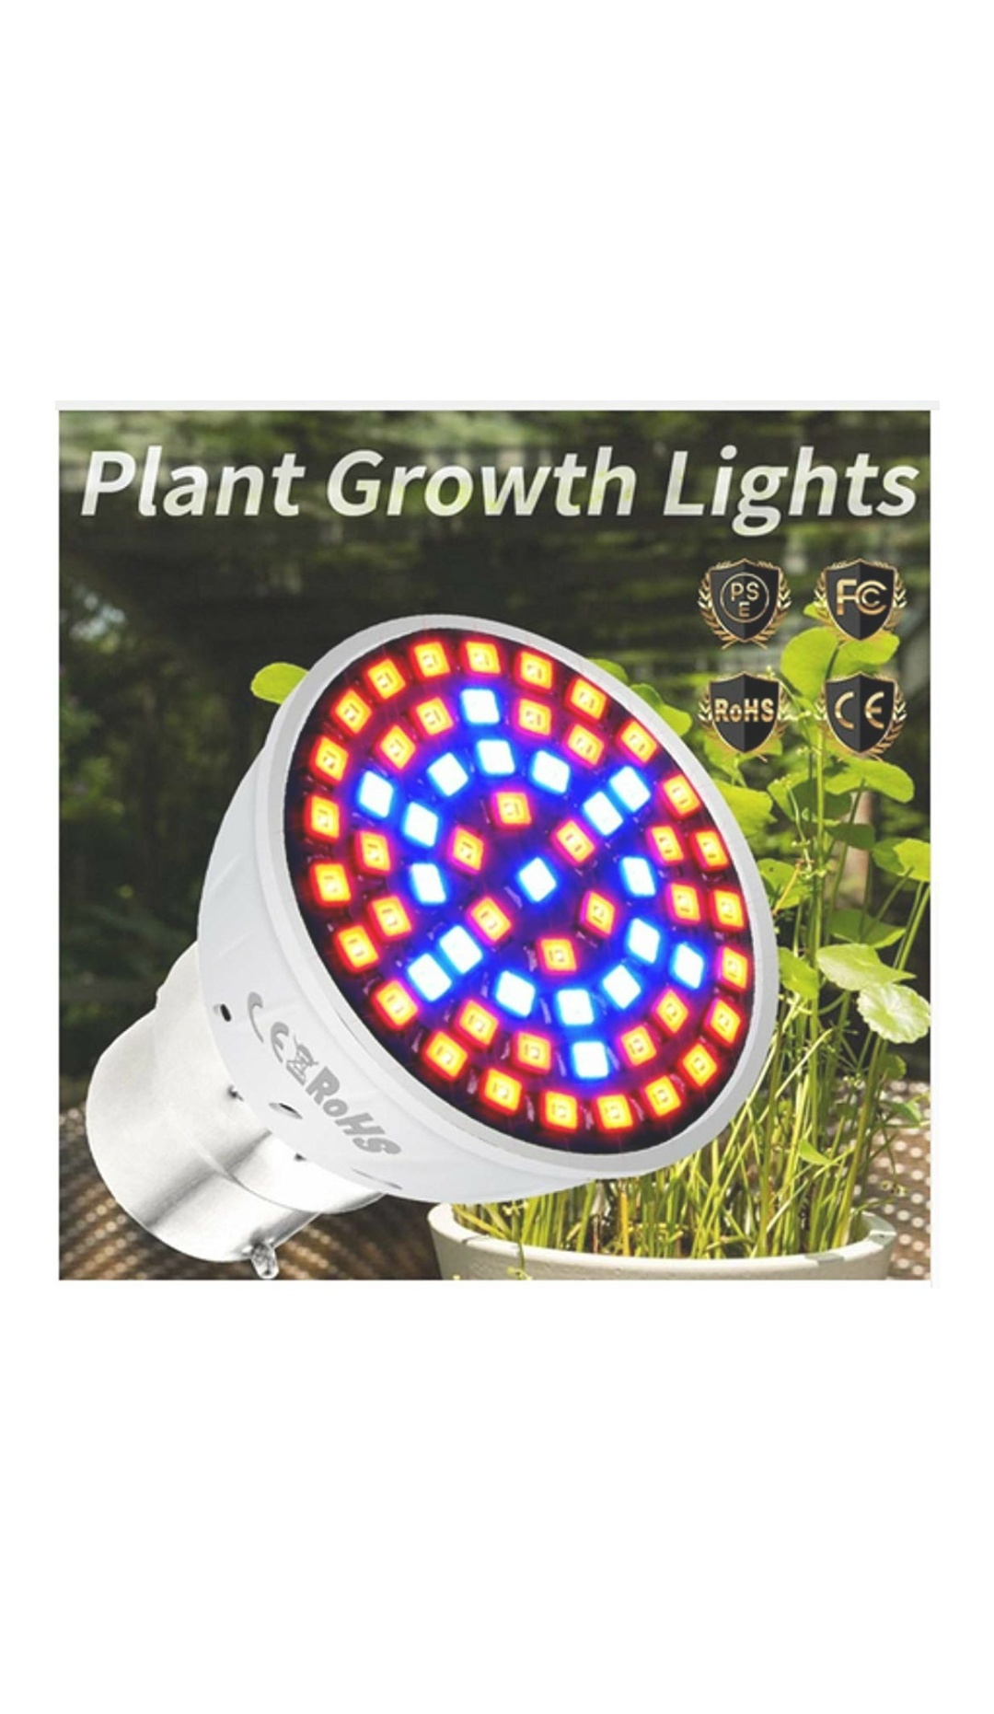

**NUTRIENTS**

-Nourishment for any plant: Ideal set of nutrients that make any plant (like vegetables,fruits,flowers or herbs) healthy. You can use it in hydroponics systems,soil or cocopeat farming.

-High quality powder concentrate: Contains highly purified concentrates for maximum solubility, optimum nutrition & even fruiting, flowering & blooming of the plant.

-Quick absorption: All the integredients are easily absorbed by the plant through the roots. The nutrient intake is extremely quick which enables the plant to focus on growing rather than spending its energy on active transport of nutrients.

**Part 1**: Micro nutrients- EpsomSalt,Borax,ManganeseSulphate,ZincSulphate,CopperSulphate,Common Salt, Ammonium Molybdyte.

**Part 2**: Iron Chellate

**Part 3**: Mono Ammonium Phosphate

**Part 4**: Calcium Nitrate

**Part 5**: Potassium Nitrate

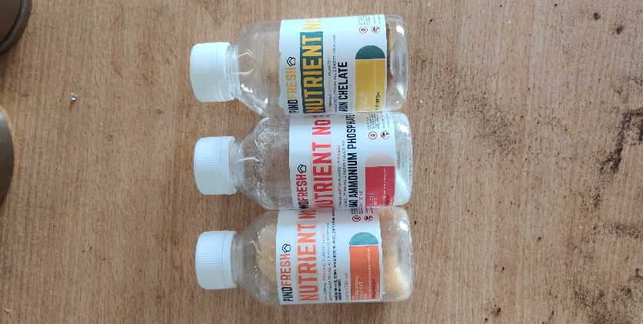

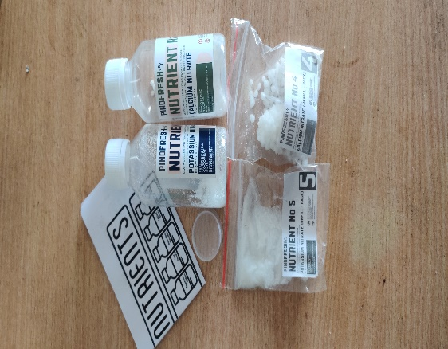

|  |  |  |  |  |  |
| --- | --- | --- | --- | --- | --- |
|  | PART 1 - MICRONUTRIENTS | PART 2 - IRON CHELATE | PART 3 - MONO AMMONIUM PHOSPHATE | PART 4 - CALCIUM NITRATE | PART 5 - POTASSIUM NITRATE |
| Benefits | Provide Photosynthesis and Respiration | Strengthens the plant and Chlorophyll (Green color) | Converts nutrients into usable building blocks for the plants to Grow. | Responsible for holding together the cell walls of plants. | Helps Plant to Grow and Reproduce |
| Symptoms of Deficiency | Wilting shoots, Poor bud development, degraded chlorophyll | Plants leaves turn yellow, then white and eventually die. | Plants become prone to disease attacks, Poor root development, Plant turns blue | New tissues such as root tips, young leaves, and shoot tips often exhibit distorted growth from improper cell wall formation. | Brown scorching,Curling of leaf tips, Plant turns yellow between leaf veins. Purple spots may also appear on the leaf undersides. |

|  |  |  |  |
| --- | --- | --- | --- |
| Type | pH balanced full spectrum plant nutrient | NPK | Seaweed Extract Potassium |
| Best used for | Hydroponic and soilless cultivation | Microgreens and seed starter | Blooming of fruiting and flowering plants |
| Leafy vegetables and herbs | ✓ | ✓ | No |
| Fruiting and flowering plants | ✓ | ✓ | ✓ |
| Contains | Part 1: Micro Nutrients - Epsom Salt, Borax, Manganese Sulphate, Zinc Sulphate, Copper Sulphate, Common Salt, Ammonium Molybdyte. Part 2: Iron Chellate Part 3: Mono Ammonium Phosphate Part 4: Calcium Nitrate Part 5: Potassium Nitrate | Calcium Nitrate, Potassium Nitrate, Mono Ammonium Phosphate | Phoolan is derived from a species of red algae kappaphycus alvarezzi, which is cultivated by self-help groups in the southern coast in India. Fresh seaweed is then processed using a patented technology to create the phoolan blooming agent. |

Yield:

* A Pindpipe can grow upto 5 plants.
* Seeds: Sow about 5-6 seeds in each net pot or transplant after germination.
* Average Output : 100 gms per net pot (For Lettuce)
* Technology Used: Deep Water Culture (DWC)

Dimensions:

* Pindpipe Length = 26 inches
* Pindpipe Diameter = 3 inches
* Stand Width = 4 inches
* Net Pot Diameter = 2 inches

Material:

* For the pipe we used Food Grade PVC.

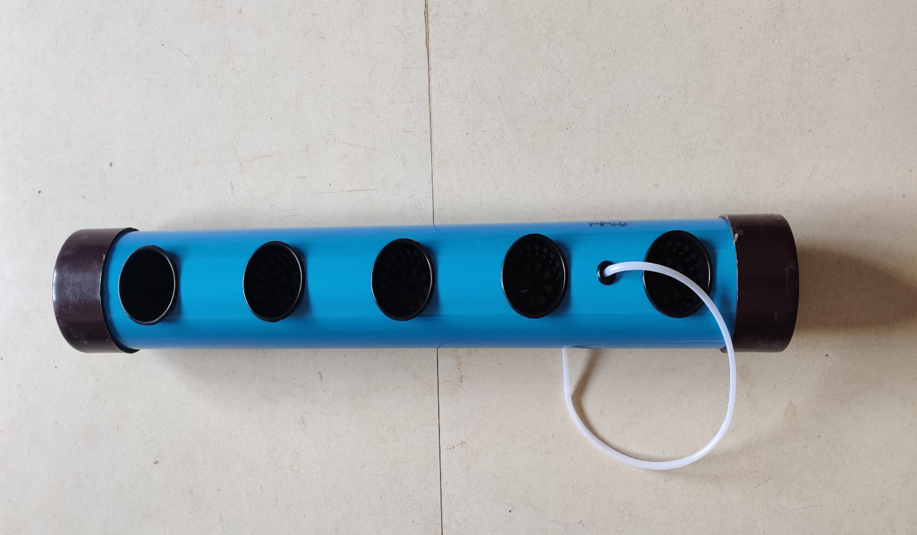

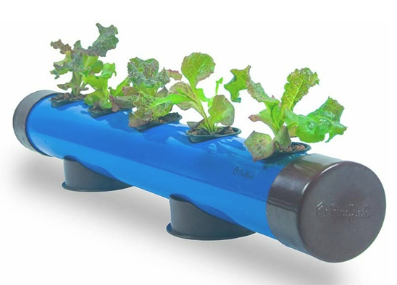

**AIR PUMP**

Plants need oxygen to survive. That's why it's super important to give them enough of this in water systems like hydroponics or aquaponics.If so, an air pump is your best friend.

Air pump is with silicone tubing and Airstone.It continuously oxygenate the water solution

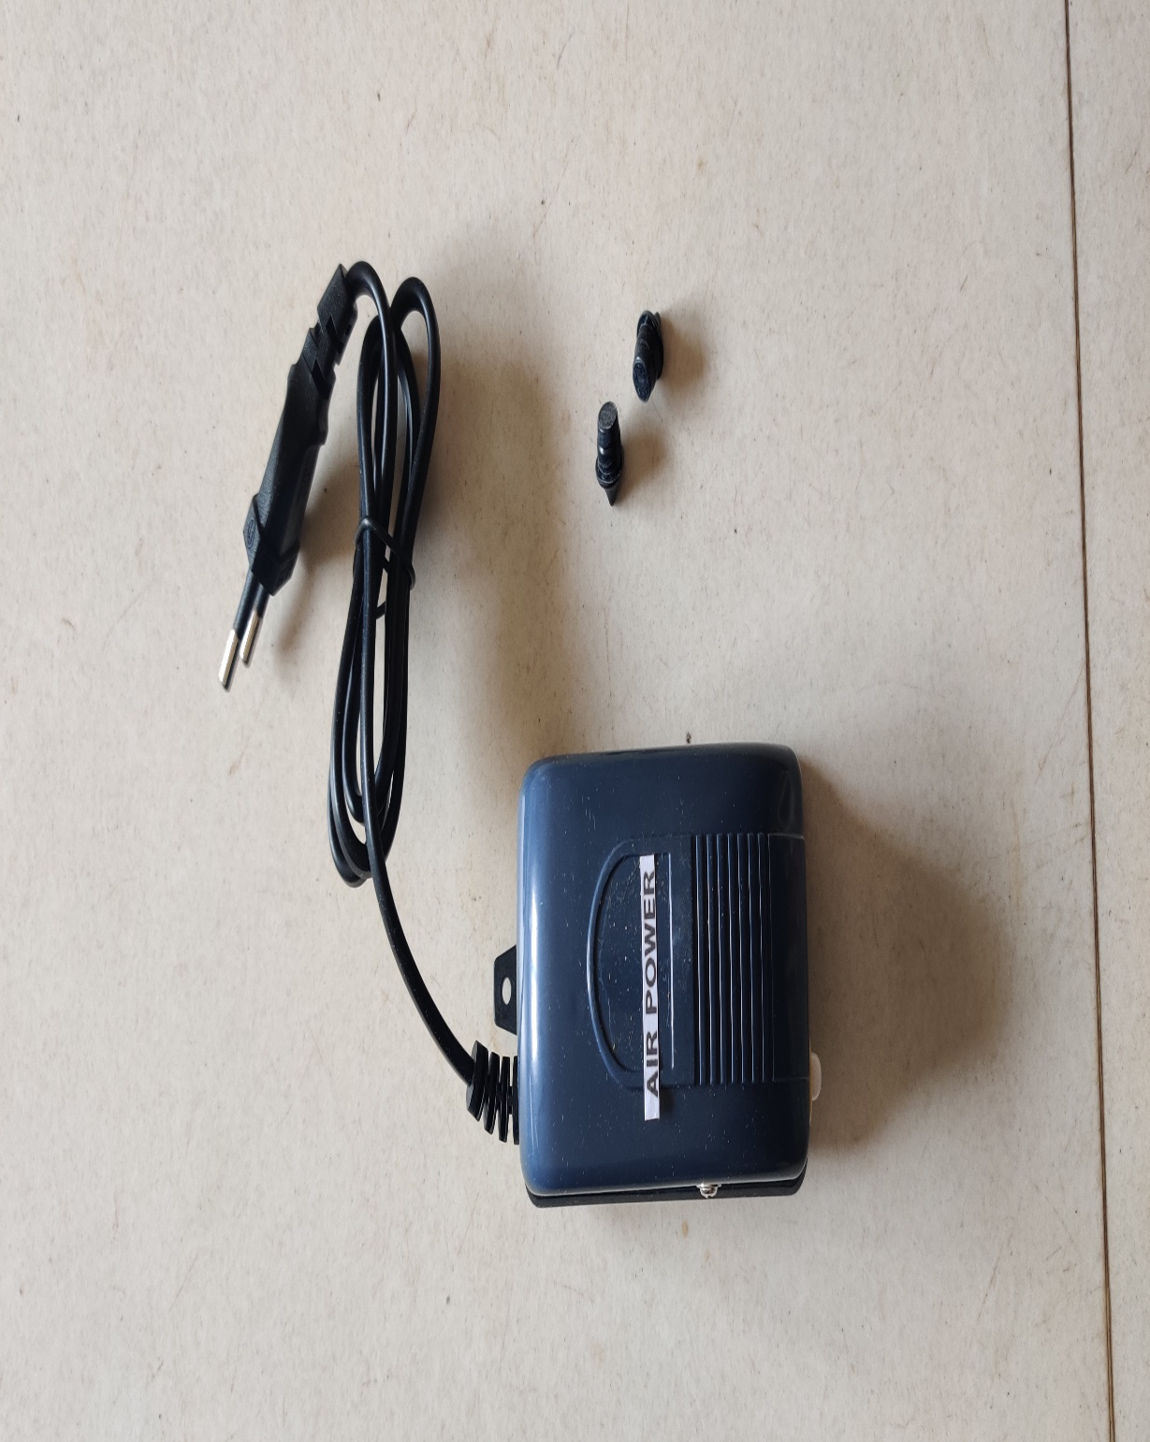

**Methodology**

* By using microcontrollers and sensors, monitoring of parameters pH, electrical conductivity(EC),and water luminosity is done.
* The microcontroller will continously monitor the water conditions where the plant is placed.
* we are monitoring pH, water conductivity and luminosity to achieve optimal growth of plants. In hydroponics the plants need to be kept at specific age value (typically 5 to 5.5) the water that we get in the tap does not have suitable pH value. The pH value had to be constantly monitored on daily bases.
* Giving lights to the plants is another major factor. In hydroponics plants need to be kept under light for 16 hours and in the dark for 8 hours to get maximum yield. For this we are using microcontroller through which we will turn ON/OFF the light .

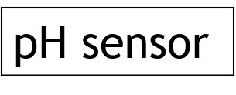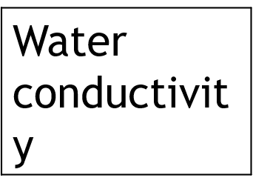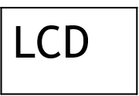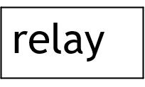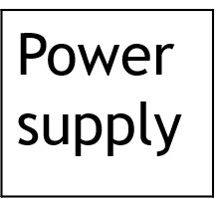

**Wiring for SSH terminal output**

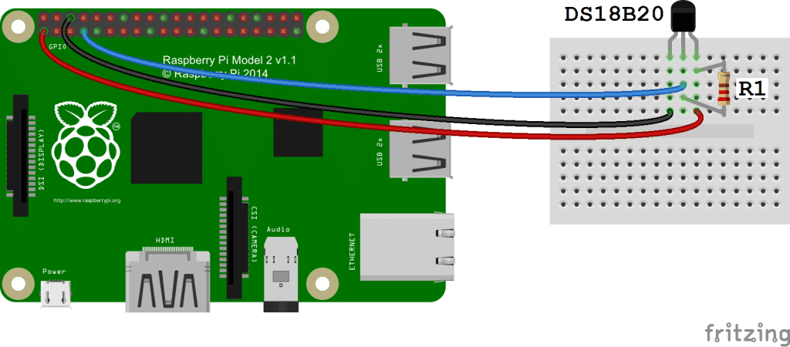

Follow this wiring diagram to output the temperature to an SSH terminal

**Wiring for LCD output**

Follow this diagram to output the temperature readings to an LCD

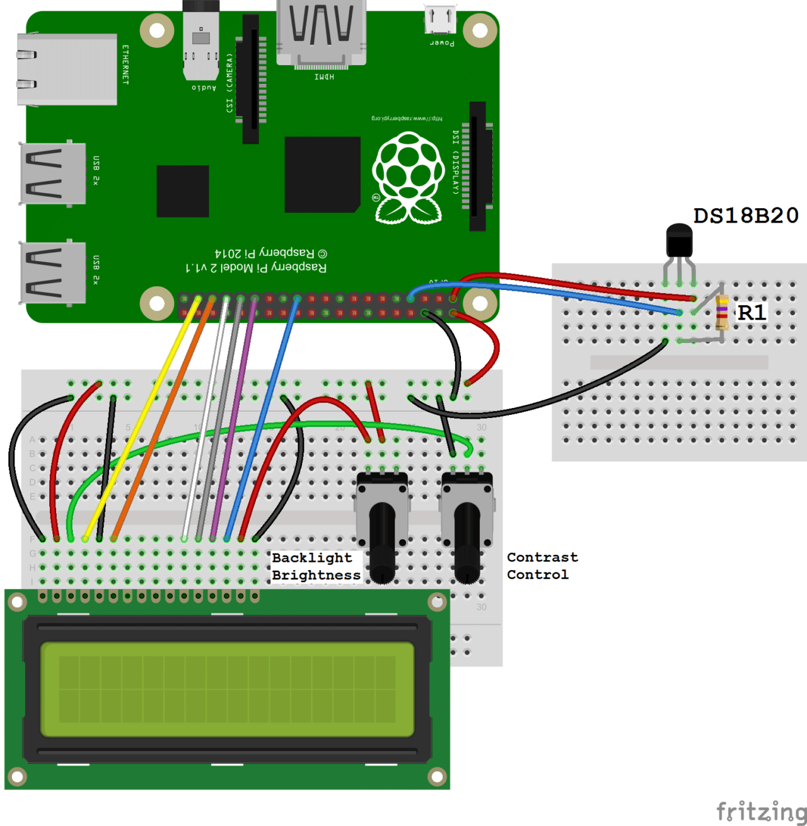

**Advantages**

1. No soil needed.
2. pH control of solution.
3. Make better use of space location.
4. Climate control.
5. Effective use of nutrients.
6. Better growth rate.
7. Labor and time saver.
8. Less space required.

**Disadvantages**

1. Requires commitment.
2. Diseases and pets may spread quickly.
3. Initial expenses.
4. Water and electricity risks.

**References**

P Sihombing,N A Karina, J T Tarigan, M I Syarif

Faculty of computer science and information technology, Universities Sumatera Utara- automated hydroponics nutrition plants systems using arduino UNO microcontroller based on android.

Masoud Torabi, Ali Akbar,Mokhtarzadeh and Mahlooji, seed and plant improvement institute(SPII), Iran-Role of hydroponics technique as a standard methodology in various aspects of plant biology researches.

Vaibhav Palande, Adam Zaheer and Kiran George, college of engineering and computer science, California state university, United States-Fully automated hydroponic system for indoor plant growth.

Jyoti Vilas Gosavi, Zeal college of engineering and research, Pune.